SCREENSHOTS FOR MACHINE PROBLEM 5(MATLAB)

**SCRIPT:**

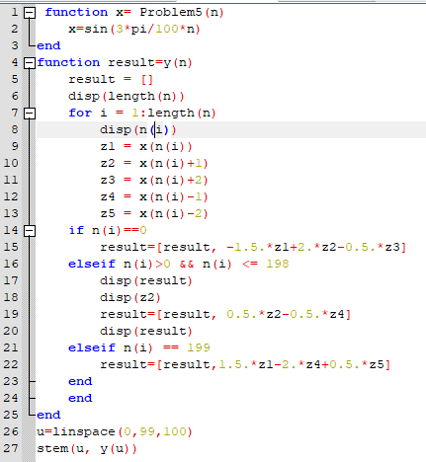

**OUTPUT:**

